# **Supplementary figures**

Supplementary Figure 1: The CoV maps generated from all eight subjects using three different protocols.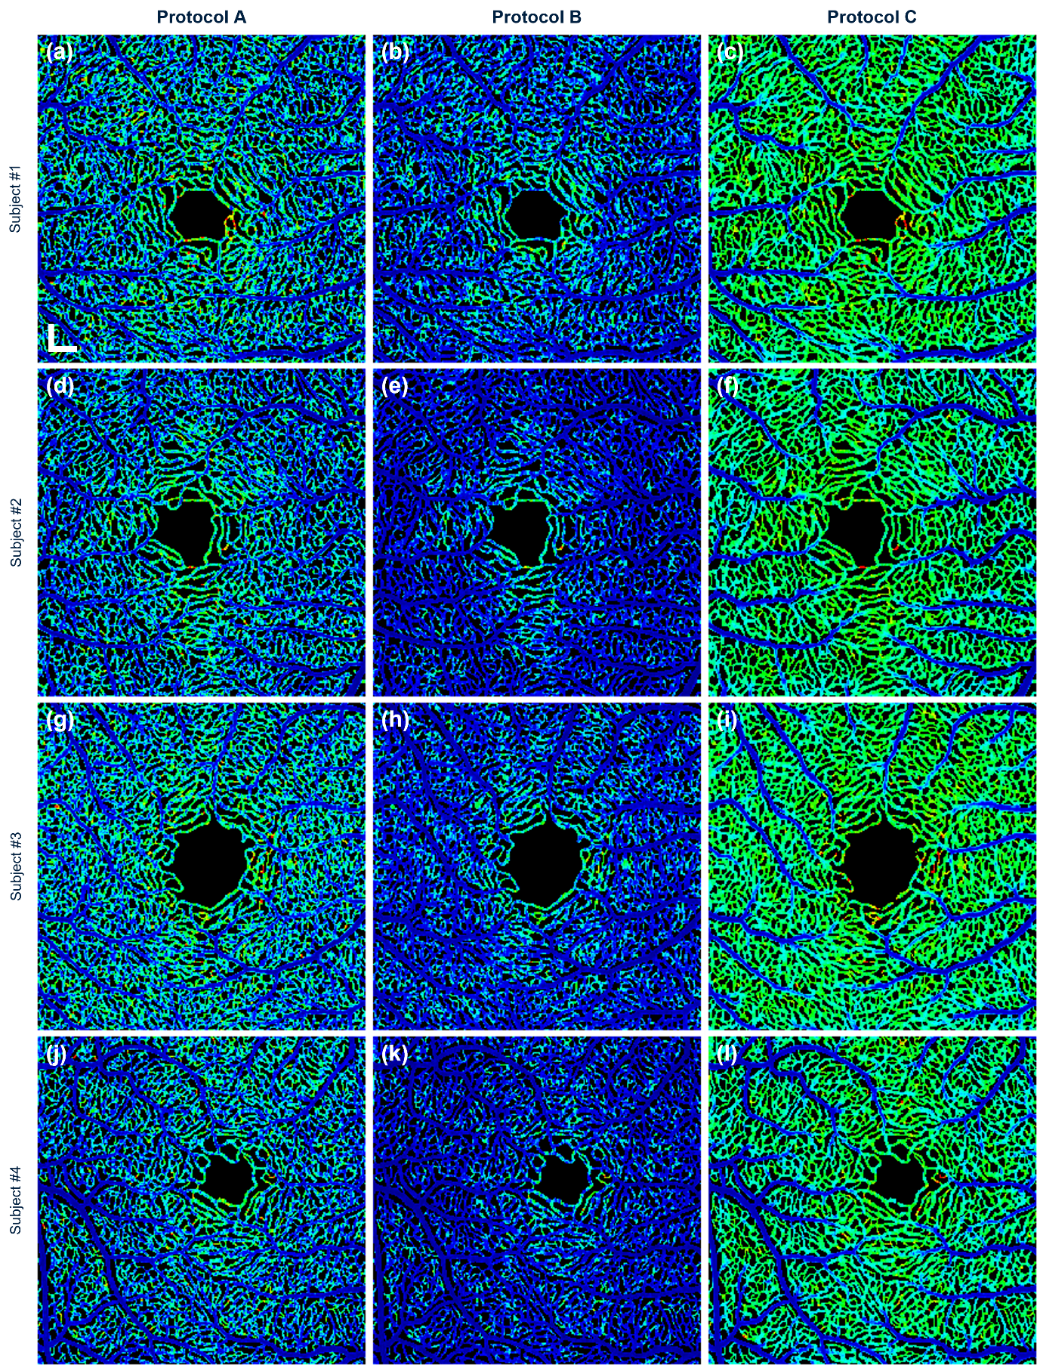

*(Continued)*

